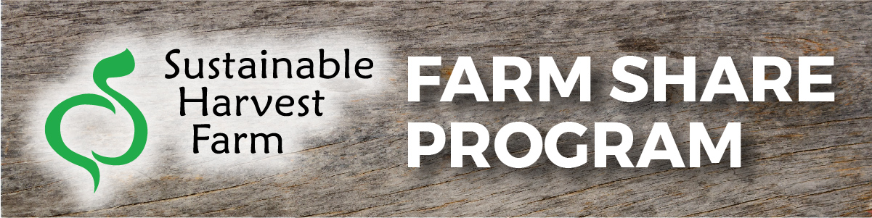
We’re excited to offer our employees the ability to sign up for a Farm Share from Sustainable Harvest Farm this year. Please take a moment to learn more about the reasons you should take advantage of this benefit. If you have any questions, please reach out to me at (insert your contact information here).
5 Reasons You Should Sign up for the Farm Share Program
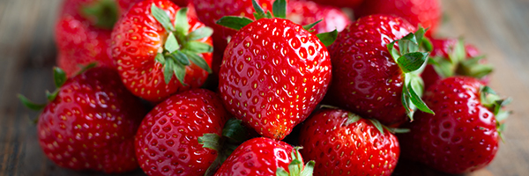
- Enjoy fresh, locally grown, USDA certified organic produce delivered right to work every week.
- You can customize your weekly share by choosing which in-season produce you want, helping you cut back on food waste.
- Have a sense of security knowing your farmer and understanding that Sustainable Harvest Farm adheres to the FDA’s food safety standards.
- Sustainable Harvest Farm has a 100% satisfaction guarantee. If you receive an item in your weekly delivery that is damaged or otherwise unacceptable, they will replace that item at no cost in the next week’s delivery.
- A University of Kentucky study showed that people who belong to Farm Share programs have increased consumption of fruits & vegetables, decreased consumption of processed foods, and fewer diet-related medical & pharmacy claims. See the study.
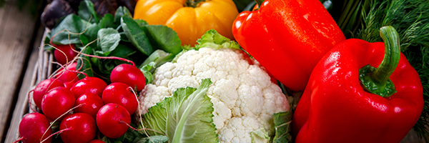
Making the Most of Your Share
As a Farm Share member, you’ll receive a weekly email that outlines what will be included in the upcoming delivery, recipes and storage tips for what you’ll be getting, and a link that allows you to customize your share.
Farm Share members also have the opportunity to add grass-fed pork and beef, cheese, and jarred items to their share, based on availability.
Sustainable Harvest Farm grows 37 varieties of vegetables & fruits throughout the growing season. See what they grow and learn more about the farm at sustainableharvestfarm.com.
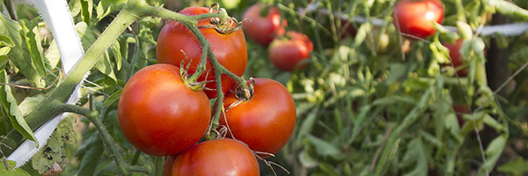
Cost & Delivery Details

Small Veggie Share – weekly produce for 1-2 people - $23/week
Regular Veggie Share – weekly produce for a family of 3-4 - $28/week
X Large Veggie Share – weekly produce for a family of 5+, or a primarily vegetarian family - $35/week
(Insert voucher information here)
Use this space to outline when, where and how Farm Share delivery and pickup will work at your location.
Learn More
Video: Get to Know Sustainable Harvest Farm
Video: How to Customize What You Get in Your Weekly Farm Share

